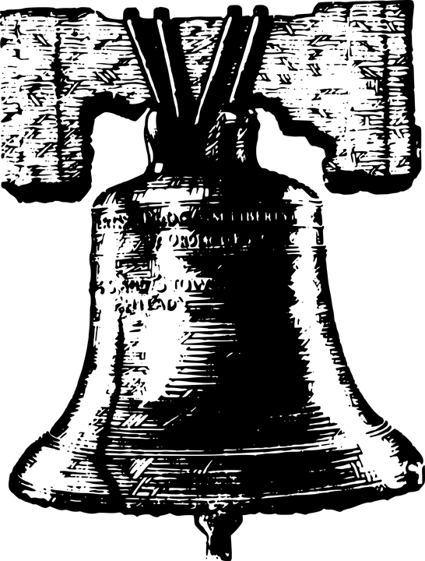
Directions for Wax Museum Project

- Choose a person to research who lived from the colonization period in America to the U.S. Civil War. See the list of possible people included with this packet.
- Read the Wax Museum Project Guidelines very carefully.
- Find the required information and record it on the Wax Museum Research Organizer, which is due Friday, May 25th.
- Record your sources on your Resources List--Wax Museum. This is also due Friday, May 25th.
- Then take the information you collected and use it to write a speech (script) for your Wax Museum presentation. You will write the final copy of your speech on the Wax Museum Speech (script) page and turn in on Wednesday, May 16th. Make sure you make a copy so you can practice!
  - Remember that you will become the character, so you will need to write it in the 1st (first) person. For example: “Hello, my name is George Washington. I was born . . . .”
  - Your script MUST be memorized!
- You will need to dress up as your character. Be creative and use things you already have at home to make your costume. A Costume Sketch page is included for you and will be due Friday, May 25th.
- Draw a background for yourself, which reflects something important from your character’s life. This background will be behind or near you during the Wax Museum.
  - Here are a few examples: George Washington lived at Mt. Vernon, so you could draw a picture of his house. Ben Franklin was famous for his kite experiment, so you could draw a picture of him flying his kite on a stormy night. John Paul Jones was a famous sea captain, so you could draw his ship battling the British.
- The date of our Wax Museum is Tuesday, June 5th, from 11am to 12:15pm.

