Wax Museum Project Guidelines
5th Grade

In this project, you will choose a person that has been a positive influential leader in American history from colonial times to the U.S. Civil War. The person you choose may also have had a negative influence or impact on American history. There will be three (3) main components to this project: research, speech (Wax Museum), and a paper.

Research:
You will conduct research about your person in class as well as at home. You will gather information from multiple sources, such as the internet and books. You will cite your sources as you have learned in order to prevent you from plagiarizing. You will use a graphic organizer to aid you in writing down the information you find. You must have at least three (3) different reliable sources (Wikipedia does not count). You must turn in your Research Organizer and your Research Source List for a grade.

Speech:
After you have gathered information about your person, you will create a one (1) minute speech that highlights your person’s life, major accomplishments, and impact or legacy. You will be required to dress up like your person and present your speech during the Wax Musuem on Tuesday, June 5th. Please make sure you refer to the Wax Museum Speech rubric. It will be used to grade your speech. You will also submit a Costume Sketch as part of the speech component (format is included in this packet).

Paper:
For the final component, you will use your research and speech to write a report about your person’s early years, accomplishments, and later years. Your paper must be written in paragraph form with the following headings: introduction, early years, accomplishments, life/death and legacy, and conclusion. Please make sure you refer to the Research Paper rubric. It will be used to grade your paper.

Due Dates:
- Wednesday, May 16th: Speech (hand-written or typed). We will practice in class, but you should also practice at home. Most of your research should be done by this point so you can write your speech and work on your paper.
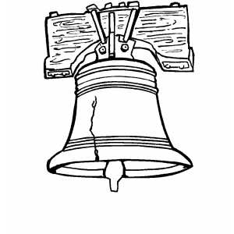
- Friday, May 25th: Research Paper (hand-written or typed), Research Organizer, and Research Source List
- Friday, May 25th: Sketch of costume (include a detailed list of the materials for the costume)
- Wax Museum Day: Tuesday, June 5th from 11:00am to 12:15pm (parents are invited to attend)

